Exam 1 Review Sheet

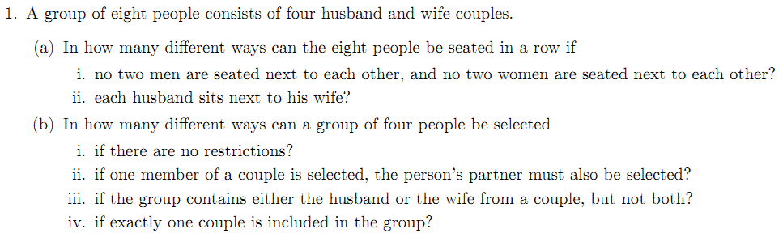

Male Female Husband Wife

2. There are two ways: MFMFMFMF and FMFMFMFM

Way 1: MFMFMFMF => 4*3*2*1*4*3*2*1 = 576 ways

Way 2: FMFMFMFM => 4*3*2*1*4*3*2*1 = 576 ways

Ans. = 576 + 576 = **1152 ways**

1. Pick 4 out of 8 people => C(8,4) = 2*7*5 = 70 ways
2. Pick 2 out of 4 couples => C(4,2) = 4*3/2*1 = 6 ways
3. Reserved
4. [H/W][H/W][ H/W][ H/W]

Pick a couple => 4 ways

Pick 2 other couples (not spoused) = 6*4/2 = 12 ways

Ans. = 4*12 = **48 ways**

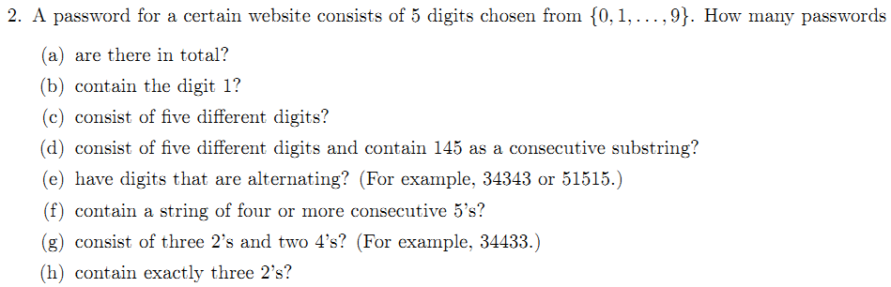

1. Pick 5 out of 10 digits to form a password => C(10,5) = 10*10*10*10*10 = 100,000
2. Pick digit ‘1’ out of the set = at least one digit ‘1’ is selected = [total] – [no digit ‘1’ is picked]

= 100,000 – 9*9*9*9*9 = 100,000 – 59,049 = **40,951**

1. Permutation with 5 out of 10 digits => P(10,5) = 10*9*8*7*6 = **30,240**
2. 145-- = 7*6 = 42 ways

-145- = 7*6 = 42 ways

--145 = 7*6 = 42 ways

Ans.: 42+42+42 = **126 ways**

2. [10][9][repeated][repeated][repeated] = 10*9 = **90**
3. Four of ‘5’ are picked

5555x => C(9,1) = 9

x5555 => C(9,1) = 9

Five of ‘5’ are picked = 55555 = **1 way**

* Ans. = 9+9+1 = **19 ways**

1. 5!/(3!2!) = 5*4*3*2*1/(3*2*1*2*1) = **10 ways**
2. [ ][ ][ ][ ][ ] Pick 3 out of 5 blanks to put digit 2’s in => C(5,3) = 5*4*3/3*2*1 = 10

Numbers of choices for two remain blanks = 9*9 = 81 note: {0,…,9}-{2}=9

* Ans. = 10 * 81 = **810 ways**

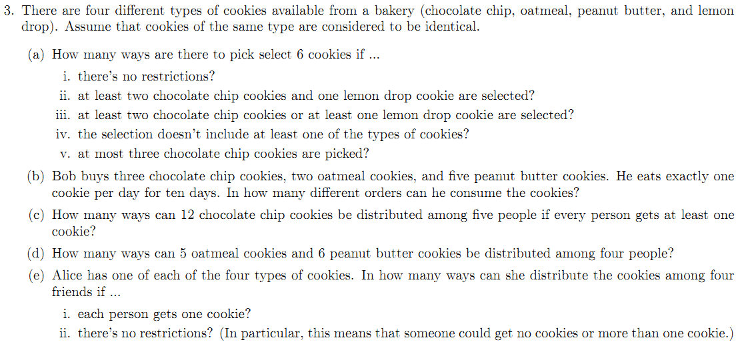

Chocolate, Oatmeal, Peanut butter, Lemon drop

1. C + O + P + L = 6 => # of ways = C(6+3,3) = C(9,3) = 9*8*7/3*2*1 = **84 ways**
2. Numbers of cookies needed to pick = 6 – 2C – 1L = 3 cookies

C + O + P + L = 3 => # of ways = C(3+3,3) = C(6,3) = 6*5*4/3*2*1= **20 ways**

1. C + O + P + L = 6-2C = 4 => # of ways = C(4+3,3) = C(7,3) = 35

C + O + P + L = 6-1L = 5 => # of ways = C(5+3,3) = C(8,3) = 56

Numbers of ways with at least 2 chocolate **AND** 1 lemon? => 20

By P.I.E => Ans. = 35 + 56 – 20 = **71 ways**

1. [the selection doesn't include at least one of the types of cookies] = …

… = [total] – [# at least one of the types of cookies are picked]

[# at least one of the types of cookies are picked] => C+O+P+L=6-1C-1O-1P-1L=2

=> C(2+3,3) = C(5,3) = 5*4*3/3*2*1 = 10 ways

So, ans. = [total] – 10 ways = 84 – 10 = **74 ways**

1. C + O + P + L = 6

[At most three C cookies are picked] = [Total] – [at least four C are picked]

[At least four C are picked] = C + O + P + L = 6-4L = 2 => C(2+3,3) = C(5,3) = 10

So, ans. = 84 – 10 = **74 ways**

1. 10!(3!2!5!) = 10*9*4*7 = **2520 ways**
2. x1 + x2 + x3 + x4 + x5 = 12 – 5*1 = 7

=> # of ways = C(7+4,4) = C(11,4) = 11*10*3 = **330** **ways**

1. Product rule:

Distribute oatmeal r=5, n=4 => C(8,3) = 56

Distribute peanut butter r=6, n=4 => C(9,3) = 84

Ans. = 84*56 = **4704 ways**

2. [B][C][A][D] => 4*3*2*1 = **24 ways**
3. [1-4][1-4][1-4][1-4] => 4*4*4*4 = **256 ways**

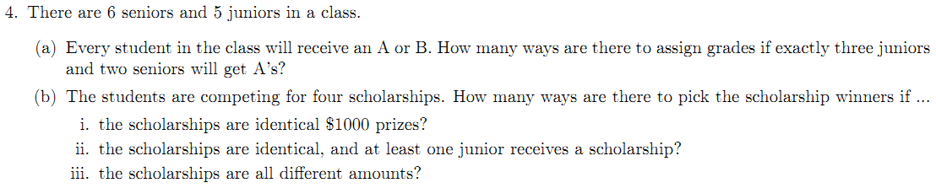

1. Reserved
2. Reserved
3. Reserved
4. 6 seniors + 5 juniors = 11 students

Ans. = [Total] – [only seniors win, means no juniors win] = 330 – C(6,4) = **315 ways**

Alt. method:

Case 1: 1J + 3S

Case 2: 2J + 2S

Case 3: 3J + 1S

Case 4: 4J + 0S

1. Reserved
3. Reserved
4. Reserved
5. Reserved